Lab 2.3.3.3 Building a Simple Network

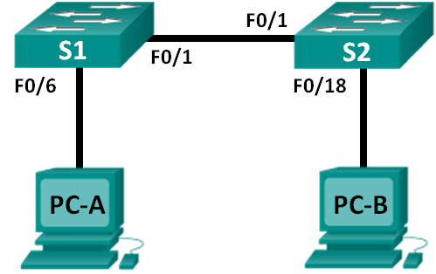

|  |  |  |  |
| --- | --- | --- | --- |
| Device | Interface | IP Address | Subnet Mask |
| PC-A | NIC | 192.168.1.10 | 255.255.255.0 |
| PC-B | NIC | 192.168.1.11 | 255.255.255.0 |

Objectives

Part 1: Set Up the Network Topology (Ethernet only)

Part 2: Configure PC Hosts

Part 3: Configure and Verify Basic Switch Settings

Background / Scenario

Networks are constructed of three major components: hosts, switches, and routers. In this lab, you will build a simple network with two hosts and two switches. You will also configure basic settings including hostname, local passwords, and login banner. Use **show** commands to display the running configuration, IOS version, and interface status. Use the **copy** command to save device configurations. You will apply IP addressing for this lab to the PCs to enable communication between these two devices. Use the **ping** utility to verify connectivity.

1. Set Up the Network Topology (Ethernet only)

In Part 1, you will cable the devices together according to the network topology.

* 1. Connect the PCs to their respective switches.
     1. Connect one end of the second Ethernet cable to the NIC port on PC-A. Connect the other end of the cable to F0/6 on S1. After connecting the PC to the switch, you should see the light for F0/6 turn amber and then green, indicating that PC-A has been connected correctly.
     2. Connect one end of the last Ethernet cable to the NIC port on PC-B. Connect the other end of the cable to F0/18 on S2. After connecting the PC to the switch, you should see the light for F0/18 turn amber and then green, indicating that the PC-B has been connected correctly.
  2. Connect the two switches.

Connect one end of an Ethernet cable to F0/1 on S1 and the other end of the cable to F0/1 on S2. You should see the lights for F0/1 on both switches turn amber and then green. This indicates that the switches have been connected correctly.

1. Configure PC Hosts
   1. Configure static IP address information on the PCs.
      1. Click the **Windows Start** icon and then select **Control Panel**.
      2. In the **Network and Internet** section, click the **View network status and tasks** link. **Note**: If the Control Panel displays a list of icons, click the drop-down option next to the **View by**: and change this option to display by **Category**.

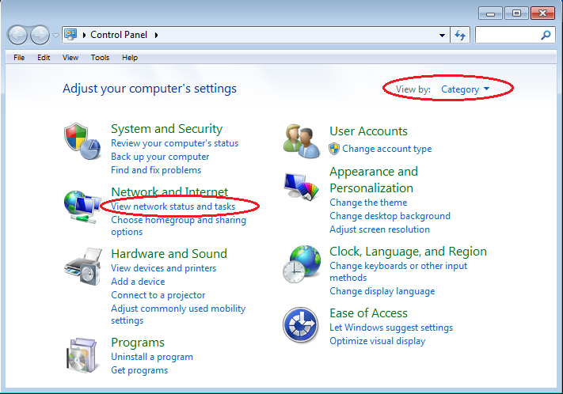

* + 1. In the left pane of the **Network and Sharing Center** window, click the **Change adapter settings** link.

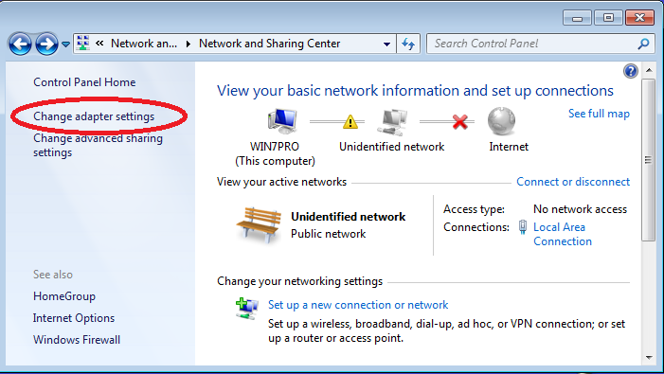

* + 1. The Network Connections window displays the available interfaces on the PC. Right-click the **Local Area Connection** interface and select **Properties**.

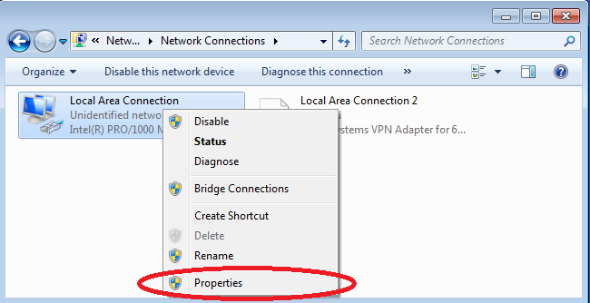

* + 1. Select the **Internet Protocol Version 4 (TCP/IPv4)** option and then click **Properties**.

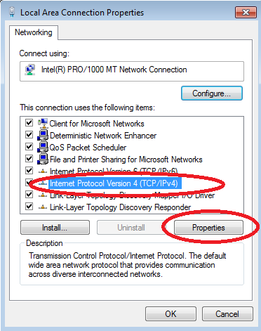

**Note**: You can also double-click **Internet Protocol Version 4 (TCP/IPv4**) to display the Properties window.

* + 1. Click the **Use the following IP address** radio button to manually enter an IP address, subnet mask, and default gateway.

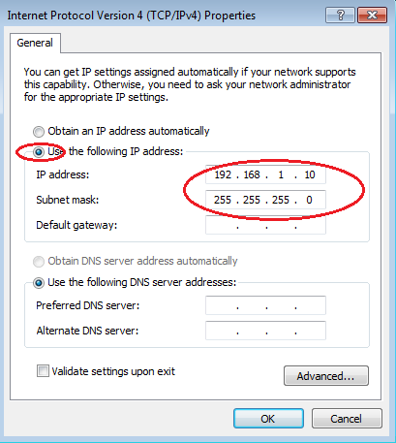

**Note**: In the above example, the IP address and subnet mask have been entered for PC-A. The default gateway has not been entered, because there is no router attached to the network. Refer to the Addressing Table on page 1 for PC-B’s IP address information.

* + 1. After all the IP information has been entered, click **OK**. Click **OK** on the Local Area Connection Properties window to assign the IP address to the LAN adapter.
    2. Repeat the previous steps to enter the IP address information for PC-B.
  1. Verify PC settings and connectivity.

Use the command prompt (**cmd.exe**) window to verify the PC settings and connectivity.

* + 1. From PC-A, click the **Windows Start** icon, type **cmd** in the **Search programs and files** box, and then press Enter.

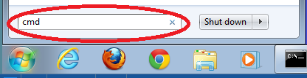

* + 1. The cmd.exe window is where you can enter commands directly to the PC and view the results of those commands. Verify your PC settings by using the **ipconfig /all** command. This command displays the PC hostname and the IPv4 address information.

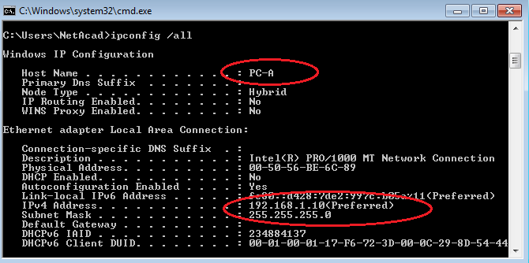

* + 1. Type **ping 192.168.1.11** and press Enter.

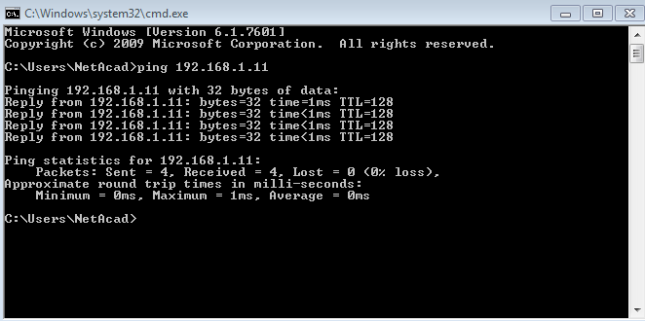

Were the ping results successful? ______________________

If not, troubleshoot as necessary.

1. Configure and Verify Basic Switch Settings
   1. Enter privileged EXEC mode.

You can access all switch commands in privileged EXEC mode. The privileged EXEC command set includes those commands contained in user EXEC mode, as well as the **configure** command through which access to the remaining command modes are gained. Enter privileged EXEC mode by entering the **enable** command.

Switch> **enable**

Switch#

The prompt changed from **Switch>** to **Switch#** which indicates privileged EXEC mode.

* 1. Enter configuration mode.

Use the **configuration terminal** command to enter configuration mode.

Switch# **configure terminal**

Enter configuration commands, one per line. End with CNTL/Z.

Switch(config)#

The prompt changed to reflect global configuration mode.

* 1. Give the switch a name.

Use the **hostname** command to change the switch name to **S1** or **S2**.

Switch(config)# **hostname S1**

S1(config)#

* 1. Prevent unwanted DNS lookups.

To prevent the switch from attempting to translate incorrectly entered commands as though they were hostnames, disable the Domain Name System (DNS) lookup.

S1(config)# **no ip domain-lookup**

* 1. Enter local passwords.

To prevent unauthorized access to the switch, passwords must be configured.

* + 1. Configure the switch password access to privileged EXEC mode.

S1(config)# **enable secret class**

* + 1. Restrict console port access. The default configuration is to allow all console connections with no password needed. Configure the console password.

S1(config)# **line con 0**

S1(config-line)# **password cisco**

S1(config-line)# **login**

S1(config-line)# **exit**

S1(config)#

* 1. Enter a login MOTD banner.

A login banner, known as the message of the day (MOTD) banner, should be configured to warn anyone accessing the switch that unauthorized access will not be tolerated.

The **banner motd** command requires the use of delimiters to identify the content of the banner message. The delimiting character can be any character as long as it does not occur in the message. For this reason, symbols, such as the **#**, are often used.

S1(config)# **banner motd #**

Enter TEXT message. End with the character '#'.

**Unauthorized access is strictly prohibited and prosecuted to the full extent of the law. #**

S1(config)# **exit**

S1#

What shortcut keys are used to go directly from global configuration mode **S1(config)#** to privileged EXEC mode **S1#**?

* 1. Save the configuration.

Use the **copy** command to save the running configuration to the startup file on non-volatile random access memory (NVRAM).

S1# **copy running-config startup-config**

Destination filename [startup-config]? **[Enter]**

Building configuration...

[OK]

* 1. Display the current configuration.

The **show running-config** command displays the entire running configuration, one page at a time. Use the spacebar to advance paging. The commands configured in Steps 1 – 8 are highlighted below.

S1# **show running-config**

Building configuration...

Current configuration : 1409 bytes

!

! Last configuration change at 03:49:17 UTC Mon Mar 1 1993

!

version 15.0

no service pad

service timestamps debug datetime msec

service timestamps log datetime msec

no service password-encryption

!

hostname S1

!

boot-start-marker

boot-end-marker

!

enable secret 4 06YFDUHH61wAE/kLkDq9BGho1QM5EnRtoyr8cHAUg.2

!

no aaa new-model

system mtu routing 1500

!

no ip domain-lookup

!

**<output omitted>**

!

banner motd ^C

Unauthorized access is strictly prohibited and prosecuted to the full extent of the law. ^C

!

line con 0

password cisco

login

line vty 0 4

login

line vty 5 15

login

!

end

* 1. Display the status of the connected interfaces on the switch.

To check the status of the connected interfaces, use the **show ip interface brief** command. Press the spacebar to advance to the end of the list.

S1# **show ip interface brief**

Interface IP-Address OK? Method Status Protocol

Vlan1 unassigned YES unset up up

FastEthernet0/1 unassigned YES unset up up

FastEthernet0/2 unassigned YES unset down down

FastEthernet0/3 unassigned YES unset down down

FastEthernet0/4 unassigned YES unset down down

FastEthernet0/5 unassigned YES unset down down

FastEthernet0/6 unassigned YES unset up up

FastEthernet0/7 unassigned YES unset down down

FastEthernet0/8 unassigned YES unset down down

FastEthernet0/9 unassigned YES unset down down

FastEthernet0/10 unassigned YES unset down down

FastEthernet0/11 unassigned YES unset down down

FastEthernet0/12 unassigned YES unset down down

FastEthernet0/13 unassigned YES unset down down

FastEthernet0/14 unassigned YES unset down down

FastEthernet0/15 unassigned YES unset down down

FastEthernet0/16 unassigned YES unset down down

FastEthernet0/17 unassigned YES unset down down

FastEthernet0/18 unassigned YES unset down down

FastEthernet0/19 unassigned YES unset down down

FastEthernet0/20 unassigned YES unset down down

FastEthernet0/21 unassigned YES unset down down

FastEthernet0/22 unassigned YES unset down down

FastEthernet0/23 unassigned YES unset down down

FastEthernet0/24 unassigned YES unset down down

GigabitEthernet0/1 unassigned YES unset down down

GigabitEthernet0/2 unassigned YES unset down down

* 1. Record the interface status for the following interfaces.

|  |  |  |  |  |
| --- | --- | --- | --- | --- |
| Interface | S1 | | S2 | |
| Status | Protocol | Status | Protocol |
| F0/1 |  |  |  |  |
| F0/6 |  |  |  |  |
| F0/18 |  |  |  |  |

1. Why are some FastEthernet ports on the switches are up and others are down?

_______________________________________________________________________________________

1. What could prevent a ping from being sent between the PCs?

_______________________________________________________________________________________